1. Brainstorming & Ideation Phase
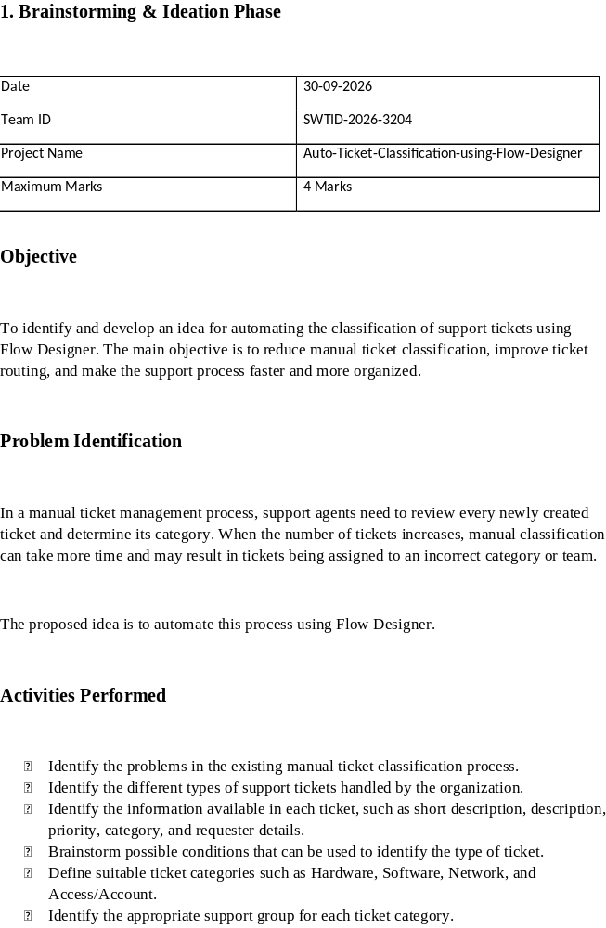
Date | 30-09-2026
Team ID | SWTID-2026-3204
Project Name | Auto-Ticket-Classification-using-Flow-Designer
Maximum Marks | 4 Marks

Objective

To identify and develop an idea for automating the classification of support tickets using Flow Designer. The main objective is to reduce manual ticket classification, improve ticket routing, and make the support process faster and more organized.

Problem Identification

In a manual ticket management process, support agents need to review every newly created ticket and determine its category. When the number of tickets increases, manual classification can take more time and may result in tickets being assigned to an incorrect category or team.

The proposed idea is to automate this process using Flow Designer.

Activities Performed

- Identify the problems in the existing manual ticket classification process.
- Identify the different types of support tickets handled by the organization.
- Identify the information available in each ticket, such as short description, description, priority, category, and requester details.
- Brainstorm possible conditions that can be used to identify the type of ticket.
- Define suitable ticket categories such as Hardware, Software, Network, and Access/Account.
- Identify the appropriate support group for each ticket category.
- Design an automated workflow for classifying newly created tickets.
- Identify the Flow Designer trigger required to start the automation.
- Define the conditions that determine the ticket category.
- Identify the actions required after classification, such as updating the category and assigning the appropriate support group.
- Discuss the expected benefits of automation, including reduced manual effort and faster ticket routing.

Proposed Idea

The proposed solution is to create a Flow Designer flow that automatically classifies a ticket when it is created.

The flow will check the available ticket information and apply predefined conditions. Based on the matching condition, the ticket will be assigned to the appropriate category and support group.

Example Classification Rules

Ticket Issue| Category| Support Group
Password/Login issue| Access/Account| Access Support
Laptop/Printer issue| Hardware| Hardware Support
Application issue| Software| Software Support
Internet/Connectivity issue| Network| Network Support

Expected / Produced Output

The brainstorming and ideation phase results in a clear automation concept:

Ticket Created → Ticket Details Checked → Classification Condition → Category Identified → Support Group Assigned → Ticket Updated

The output of this phase is a finalized idea and basic workflow for implementing automatic ticket classification using Flow Designer.

Expected Benefits

- Reduction in manual ticket classification.
- Faster routing of tickets.
- Consistent ticket categorization.
- Reduction in classification errors.
- Better utilization of support team resources.
- Improved visibility of ticket status and assignment.

Screenshots

Screenshot 1
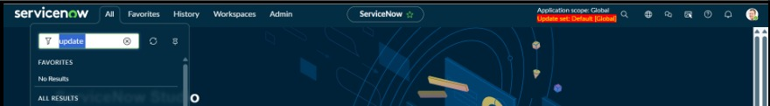
Screenshot 2
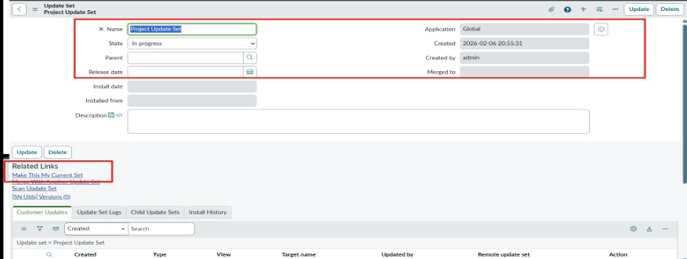
Screenshot 3
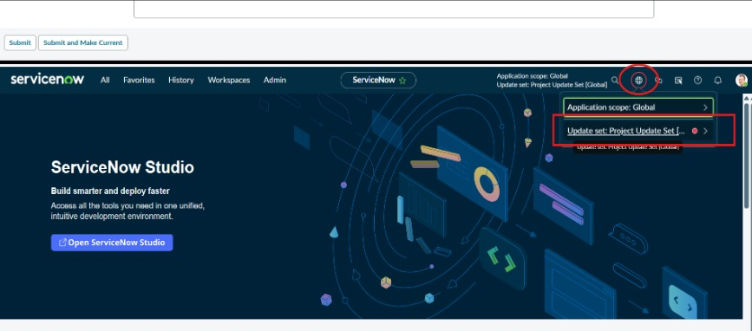

Data Flow Diagram
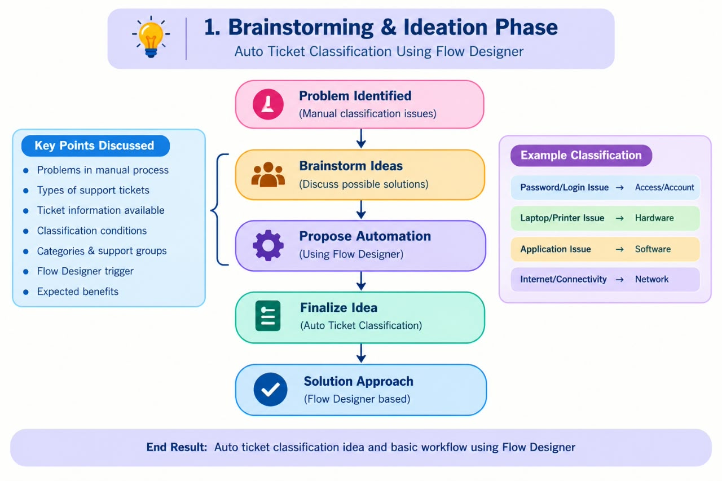

Conclusion

The brainstorming and ideation phase establishes the concept of using Flow Designer to automate ticket classification. The identified requirements, classification rules, and workflow provide the foundation for the next phases of requirement analysis, design, planning, development, and testing.

